Assignment 3 HTML AND CSS

1. Tribute page
2. <html><head>
3. <title>
4. </title>
5. </head>
6. <body background="C:\Users\Sarika\Pictures\Saved Pictures\mine\IMG_20180226_225012_806 - Copy.jpg">
7. <table border="5px" cellpadding="10" cellspacing="7">
8. <tr>
9. <td colspan = "2"  bgcolor="SKYBLUE" >


13. <font align="right" font family="Castellar" font style="Bold Italic" font size="100px">Ratan Tata<br>
14. </font>

17. <pre>
18. <font color="black" font size="3px" font style="italic" align="right" font family="Castellar">
19. <a href="https://en.wikipedia.org/w/index.php?title=Ratan_Tata&action=edit"> <b>View Source </b></a>    <a href="https://en.wikipedia.org/wiki/Wikipedia:About"><b>About us</b></a>     <a href="https://en.wikipedia.org/wiki/Wikipedia:Contact_us"><b>Contact Wickipedia</b></a>
21. </pre>
22. </font>
23. </td>
24. </tr>
25. <tr>
26. <td colspan = "2" bgcolor = "b5dcb3" >
28. <h4>Occupation</h4>
29. 1.Businessm </br>
30. 2.anphil </br>
31. 3.anthropistinvestor<br>
33. </td>
34. </tr>
35. <tr>
36. <td colspan = "2" bgcolor = "lightgrey">
37. <h3 class="text-center">Here's a timeline of RATAN TATA Sir life:</h3>
38. <h4 class="text-center">“I don't believe in taking right decisions. I take decisions and then make them right.”</h4>
39. <p class="text-center">- <em><small>RATAN TATA</small></em></p>
40. <img src="Ratan Tata.jpg" height=300px width=400px alt="natural" align="left"  />
41. </div>
42. </div>
43. <hr />
44. <div style="float:left">
45. <i>R</i>atan Tata was born in Bombay, now Mumbai, during the British Raj on 28 December 1937, and is the son of Naval Tata (born in Surat). His biological maternal grandmother had been the sister of Hirabai Tata, wife of group founder Jamsetji Tata. His biological grandfather, Hormusji Tata, had belonged to the broader Tata family; Ratan therefore was a Tata by birth. Parents Naval and Sonoo separated in 1948 when Ratan was 10, and he was subsequently raised by the widow of Sir Ratanji Tata, his grandmother, Navajbai Tata, who formally adopted him through the J. N. Petit Parsi Orphanage. He has a half-brother, Noel Tata (from Naval Tata's second marriage with Simone Tata), with whom he was raised. His first language is Gujarati.
47. During the 21 years he led the Tata Group, revenues grew over 40 times, and profit, over 50 times. Where sales of the group as a whole, overwhelmingly came from commodities when he took over, the majority sales came from brands when he exited. He boldly got Tata Tea to acquire Tetley, Tata Motors to acquire Jaguar Land Rover and Tata Steel to acquire Corus. All this turned Tata from a largely India-centric group into a global business, with over 65% revenues coming from operations and sales in over 100 countries. He conceptualised the Tata Nano car. In 2015, He explained in an interview for the Harvard Business School's Creating Emerging Markets project, the development of the Tata Nano was significant because it helped put cars at a price-point within reach of the average Indian consumer.
49. Ratan Tata resigned his executive powers in the Tata group on 28 December 2012, upon turning 75 and Board of Directors and Legal division refused to appoint Cyrus Mistry as a successor of 44-year-old son of Pallonji Mistry of the Shapoorji Pallonji Group, the largest individual shareholder of the group and related by marriage. On 24 October 2016, Cyrus Mistry was removed as the chairman of Tata Sons and Ratan Tata was made interim chairman. The decision went through intense media scrutiny that made many scrutinize the root causes of the sudden removal, and the resultant crisis.[25] A selection committee was formed to find a successor. The selection committee consisted of Mr. Tata, TVS Group head Venu Srinivasan, Amit Chandra of Bain Capital, former diplomat Ronen Sen and Lord Kumar Bhattacharya. All of them, except Mr. Bhattacharya, were on the board of Tata Sons.[26] On 12 January 2017, Natarajan Chandrasekaran was named as the chairman of Tata Sons, a role he assumed in February 2017.
51. He studied at the Campion School, Mumbai till the 8th class, followed by Cathedral and John Connon School, Mumbai and at Bishop Cotton School in Shimla,[10] and, in 1955, graduated from Riverdale Country School in New York City.[11][12] In 1959, he then received a degree in Architecture from Cornell University, and in 1975, attended the seven-week Advanced Management Program of Harvard Business School — an institution which he has since endowed.
52. </div>
54. </td>
55. </tr>
56. <tr>
57. <td colspan = "2" bgcolor = "#b5dcb3">
58. <center>
59. <pre>
60. <h1> Latest News....</h1>
61. <div align="left">
62. <center>
63. <iframe width="220" height="245" src="https://www.youtube.com/watch?v=KhSIQy7wGzo">
64. </iframe>

67. NEW DELHI: Tata Sons chairman N Chandrasekaran on Thursday met Prime Minister Narendra Modi in
68. Delhi ahead of the official handover of Air India to the Tata Group.
69. Chandrasekaran also visited the Air India headquarters after the meeting with PM Modi.
70. </center>
71. </td>
72. </tr>
74. <tr>
75. <td  bgcolor = "#b5dcb3"></td>
76. <center>
77. <tr>
78. <td  bgcolor = "#b5dcb3">
79. <center>
80. <a href="https://en.wikipedia.org/wiki/Ratan_Tata">Wickipidea@Copyriht</a>
81. </center>
82. </td>
83. </tr>

86. </table>
87. </body>
88. </html>

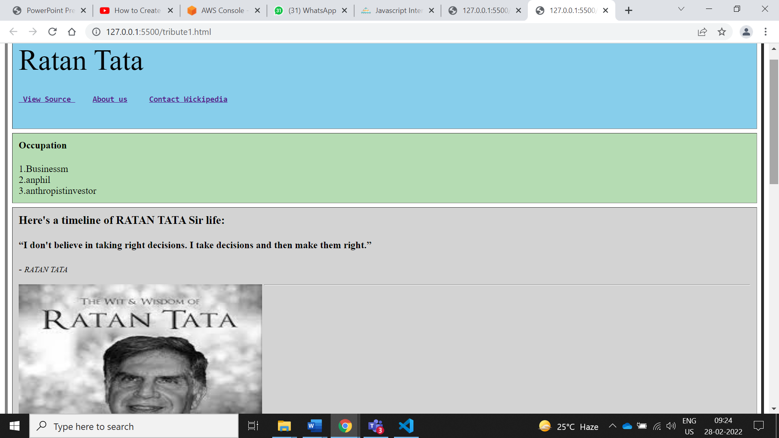

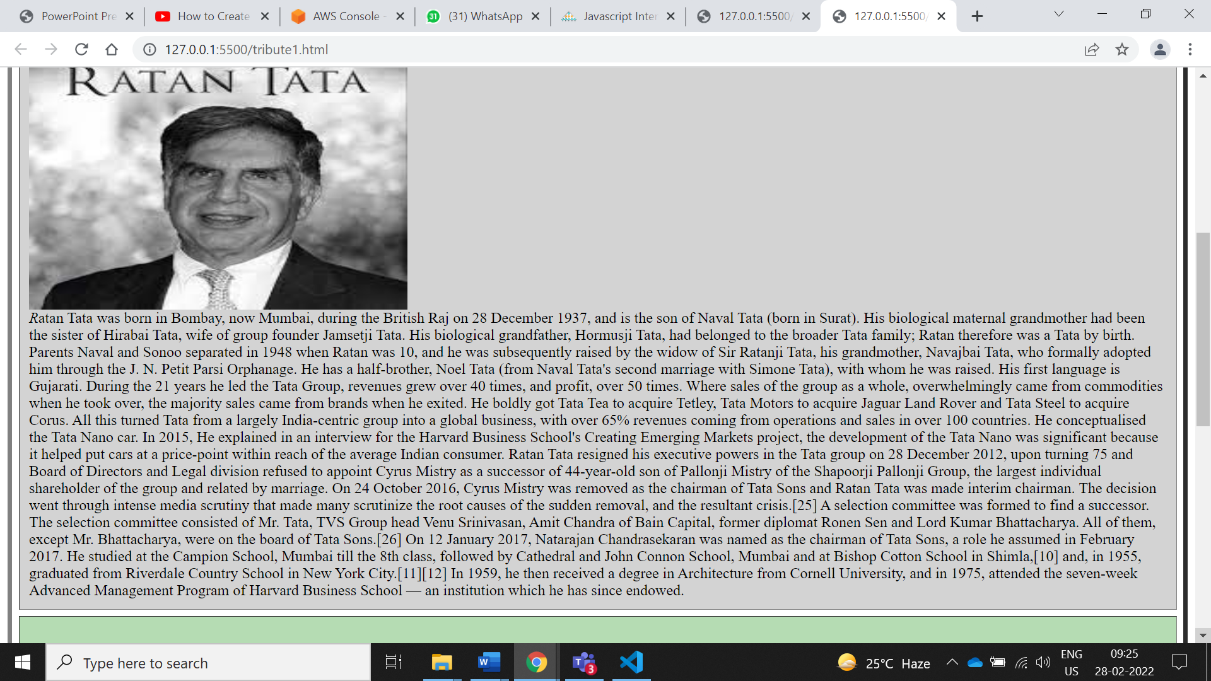

Login Page.

<!DOCTYPE html>

<html>

<head>

<meta name="viewport" content="width=device-width, initial-scale=1">

<style>

body{

  font-family: Calibri, Helvetica, sans-serif;

  background-color: pink;

}

.container {

    padding: 50px;

  background-color: #b5dcb3;

}

input[type=text], input[type=password], textarea {

  width: 70%;

  padding: 15px;

  margin: 5px 0 22px 0;

  display: inline-block;

  border: none;

  background: #f1f1f1;

}

input[type=text]:focus, input[type=password]:focus {

  background-color: orange;

  outline: none;

}

 div {

            padding: 10px 0;

         }

hr {

  border: 1px solid #f1f1f1;

  margin-bottom: 25px;

}

.registerbtn {

  background-color: #4CAF50;

  color: white;

  padding: 16px 20px;

  margin: 8px 0;

  border: none;

  cursor: pointer;

  width: 100%;

  opacity: 0.9;

}

.registerbtn:hover {

  opacity: 1;

}

</style>

</head>

<body>

<form>

  <div class="container">

  <center>  <h1>  Registeration Form</h1> </center>

  <hr>

  <label> Firstname </label>

<input type="text" name="firstname" placeholder= "Firstname" size="15" required />

<label> Middlename: </label>

<input type="text" name="middlename" placeholder="Middlename" size="15" required />

<label> Lastname: </label>

<input type="text" name="lastname" placeholder="Lastname" size="15"required />

<div>

<label>

Course :

</label>

<select>

<option value="Course">Field</option>

<option value="BCA">IT</option>

<option value="BBA">CS</option>

<option value="B.Tech">ETC</option>

<option value="MBA">CIVIL</option>

<option value="MCA">Mechanical</option>

<option value="M.Tech">M.Tech</option>

</select>

</div>

<div>

<label>

Gender :

</label><br>

<input type="radio" value="Male" name="gender" checked > Male

<input type="radio" value="Female" name="gender"> Female

<input type="radio" value="Other" name="gender"> Other

</div>

<label>

Phone :

</label>

<input type="text" name="country code" placeholder="Country Code"  value="+91" size="2"/>

<input type="text" name="phone" placeholder="phone no." size="10"/ required>

Current Address :

<textarea cols="80" rows="5" placeholder="Current Address" value="address" required>

</textarea>

 <label for="email"><b>Email</b></label>

 <input type="text" placeholder="Enter Email" name="email" required>

    <label for="psw"><b>Password</b></label>

    <input type="password" placeholder="Enter Password" name="psw" required>

    <label for="psw-repeat"><b>Re-type Password</b></label>

    <input type="password" placeholder="Retype Password" name="psw-repeat" required>

    <button type="submit" class="registerbtn">Register</button>

</form>

</body>

</html>

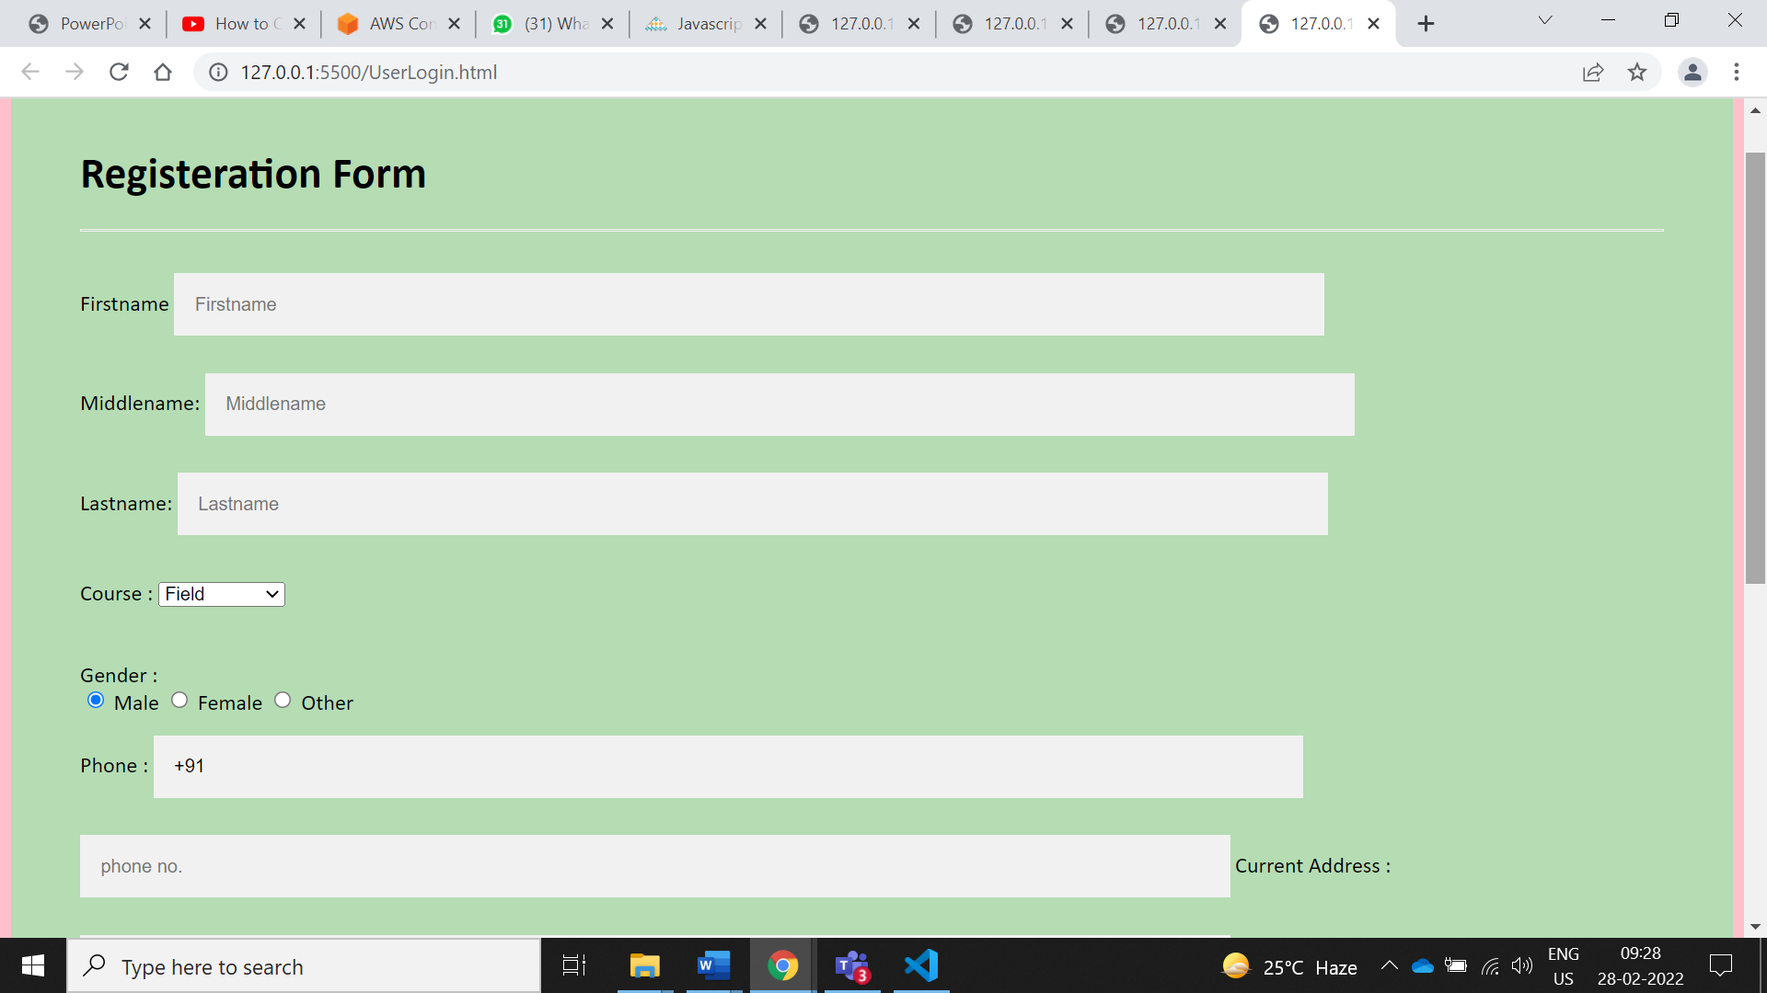

Restro Website

<!DOCTYPE html>

<html>

<head>

<title>Restro Website</title>

<meta charset="UTF-8">

<meta name="viewport" content="width=device-width, initial-scale=1">

<link rel="stylesheet" href="https://www.w3schools.com/w3css/4/w3.css">

<style>

body {font-family: "Times New Roman", Georgia, Serif;}

h1, h2, h3, h4, h5, h6 {

  font-family: "Playfair Display";

  letter-spacing: 5px;

}

</style>

</head>

<body>

<!-- Navbar (sit on top) -->

<div class="w3-top">

  <div class="w3-bar w3-white w3-padding w3-card" style="letter-spacing:4px;">

    <a href="#home" class="w3-bar-item w3-button">Restaurant  & Catering</a>

    <!-- Right-sided navbar links. Hide them on small screens -->

    <div class="w3-right w3-hide-small">

      <a href="#about" class="w3-bar-item w3-button">About</a>

      <a href="#menu" class="w3-bar-item w3-button">Menu</a>

      <a href="#contact" class="w3-bar-item w3-button">Contact</a>

    </div>

  </div>

</div>

<!-- Header -->

<header class="w3-display-container w3-content w3-wide" style="max-width:1600px;min-width:500px" id="home">

  <img class="w3-image" src="/images/hamburger.jpg" alt="Hamburger Catering" width="1600" height="800">

  <div class="w3-display-bottomleft w3-padding-large w3-opacity">

    <h1 class="w3-xxlarge"> Catering</h1>

  </div>

</header>

<!-- Page content -->

<div class="w3-content" style="max-width:1100px">

  <!-- About Section -->

  <div class="w3-row w3-padding-64" id="about">

    <div class="w3-col m6 w3-padding-large w3-hide-small">

     <img src="/images/tablesetting2.jpg" class="w3-round w3-image w3-opacity-min" alt="Table Setting" width="600" height="750">

    </div>

    <div class="w3-col m6 w3-padding-large">

      <h1 class="w3-center">About Catering</h1><br>

      <h5 class="w3-center">Tradition since 1889</h5>

      <p class="w3-large">The Catering was founded rathods in India, We only use <span class="w3-tag w3-light-grey">seasonal</span> ingredients.</p>

      <p class="w3-large w3-text-grey w3-hide-medium">

        Good food is always cooking! Go ahead, order some yummy items from the menu..</p>

    </div>

  </div>

  <hr>

  <!-- Menu Section -->

  <div class="w3-row w3-padding-64" id="menu">

    <div class="w3-col l6 w3-padding-large">

      <h1 class="w3-center">Our Menu</h1><br>

      <h4>Bread Basket</h4>

      <p class="w3-text-grey">Assortment of fresh baked fruit breads and muffins 5.50</p><br>

      <h4>Honey Almond Granola with Fruits</h4>

      <p class="w3-text-grey">Natural cereal of honey toasted oats, raisins, almonds and dates 7.00</p><br>

      <h4>Belgian Waffle</h4>

      <p class="w3-text-grey">Vanilla flavored batter with malted flour 7.50</p><br>

      <h4>Scrambled eggs</h4>

      <p class="w3-text-grey">Scrambled eggs, roasted red pepper and garlic, with green onions 7.50</p><br>

      <h4>Blueberry Pancakes</h4>

      <p class="w3-text-grey">With syrup, butter and lots of berries 8.50</p>

    </div>

    <div class="w3-col l6 w3-padding-large">

      <img src="/images/tablesetting.jpg" class="w3-round w3-image w3-opacity-min" alt="Menu" style="width:100%">

    </div>

  </div>

  <hr>

  <!-- Contact Section -->

  <div class="w3-container w3-padding-64" id="contact">

    <h1>Contact</h1><br>

    <p>We offer full-service catering for any event, large or small. We understand your needs and we will cater the food to satisfy the biggerst criteria of them all, both look and taste. Do not hesitate to contact us.</p>

    <p class="w3-text-blue-grey w3-large"><b>Catering Service, 42nd Living St, 43043 New York, NY</b></p>

    <p>You can also contact us by phone 00553123-2323 or email catering@catering.com, or you can send us a message here:</p>

    <form action="/action_page.php" target="_blank">

      <p><input class="w3-input w3-padding-16" type="text" placeholder="Name" required name="Name"></p>

      <p><input class="w3-input w3-padding-16" type="number" placeholder="How many people" required name="People"></p>

      <p><input class="w3-input w3-padding-16" type="datetime-local" placeholder="Date and time" required name="date" value="2020-11-16T20:00"></p>

      <p><input class="w3-input w3-padding-16" type="text" placeholder="Message \ Special requirements" required name="Message"></p>

      <p><button class="w3-button w3-light-grey w3-section" type="submit">SEND MESSAGE</button></p>

    </form>

  </div>

<!-- End page content -->

</div>

<!-- Footer -->

<footer class="w3-center w3-light-grey w3-padding-32">

  <p>Powered by <a href="https://www.w3schools.com/w3css/default.asp" title="W3.CSS" target="_blank" class="w3-hover-text-green">w3.css</a></p>

</footer>

</body>

</html>

Restro website

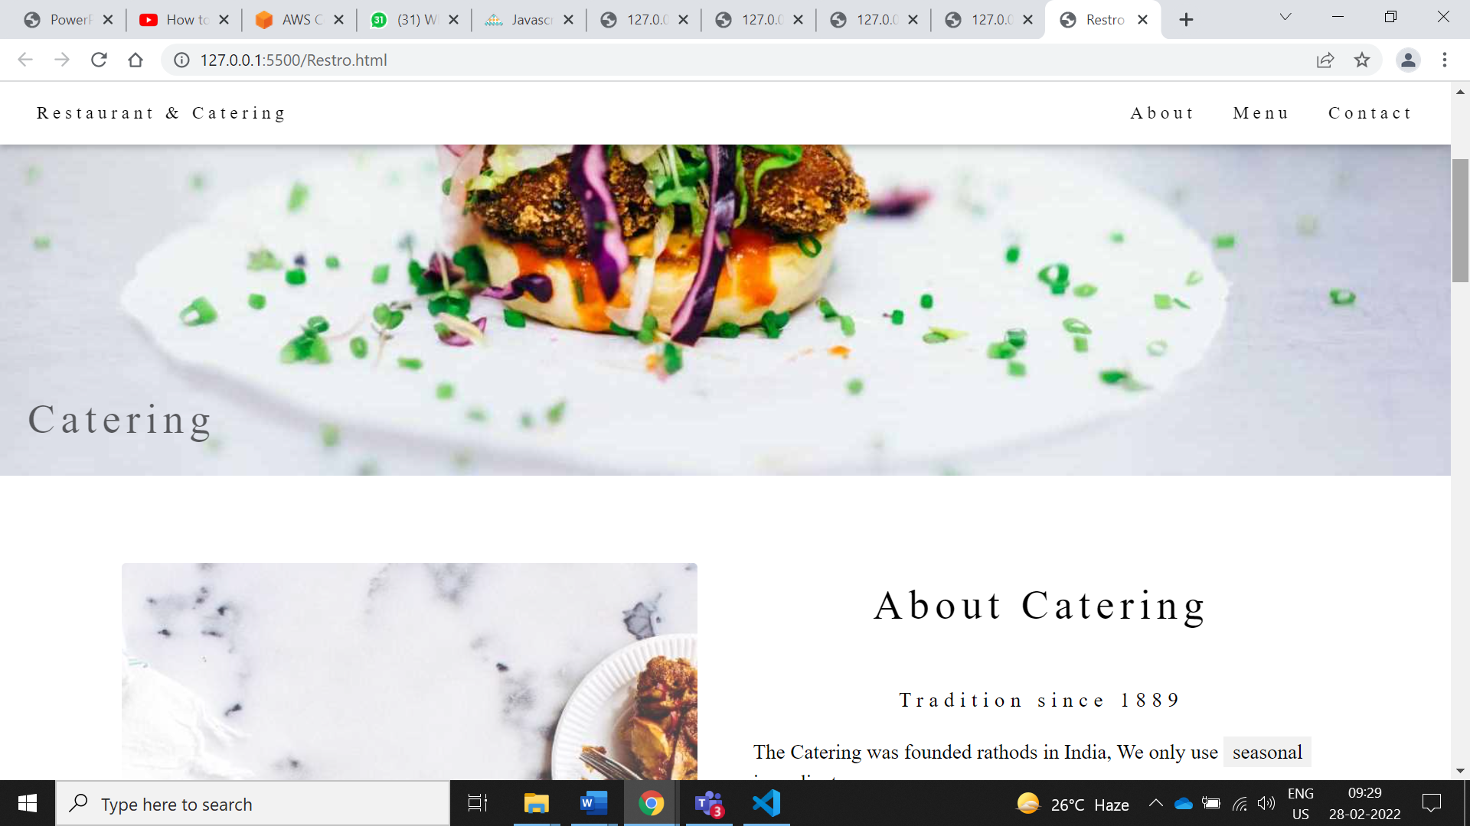

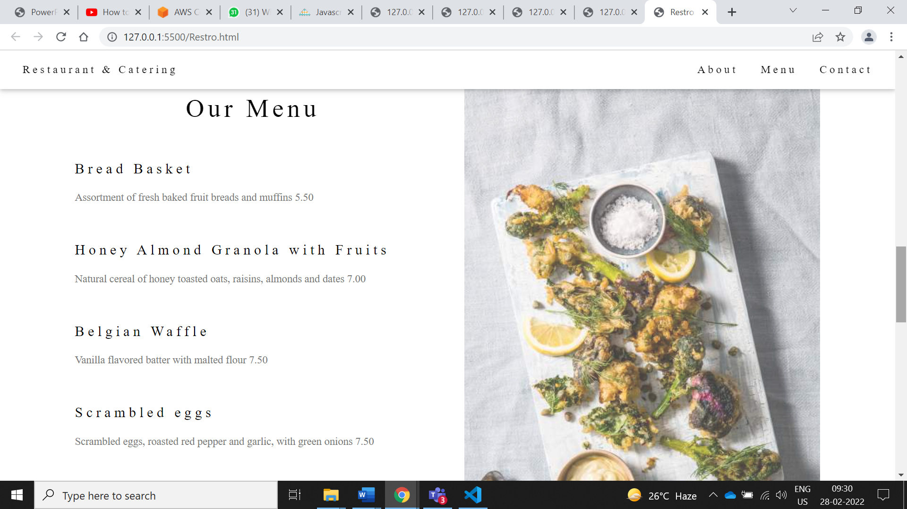

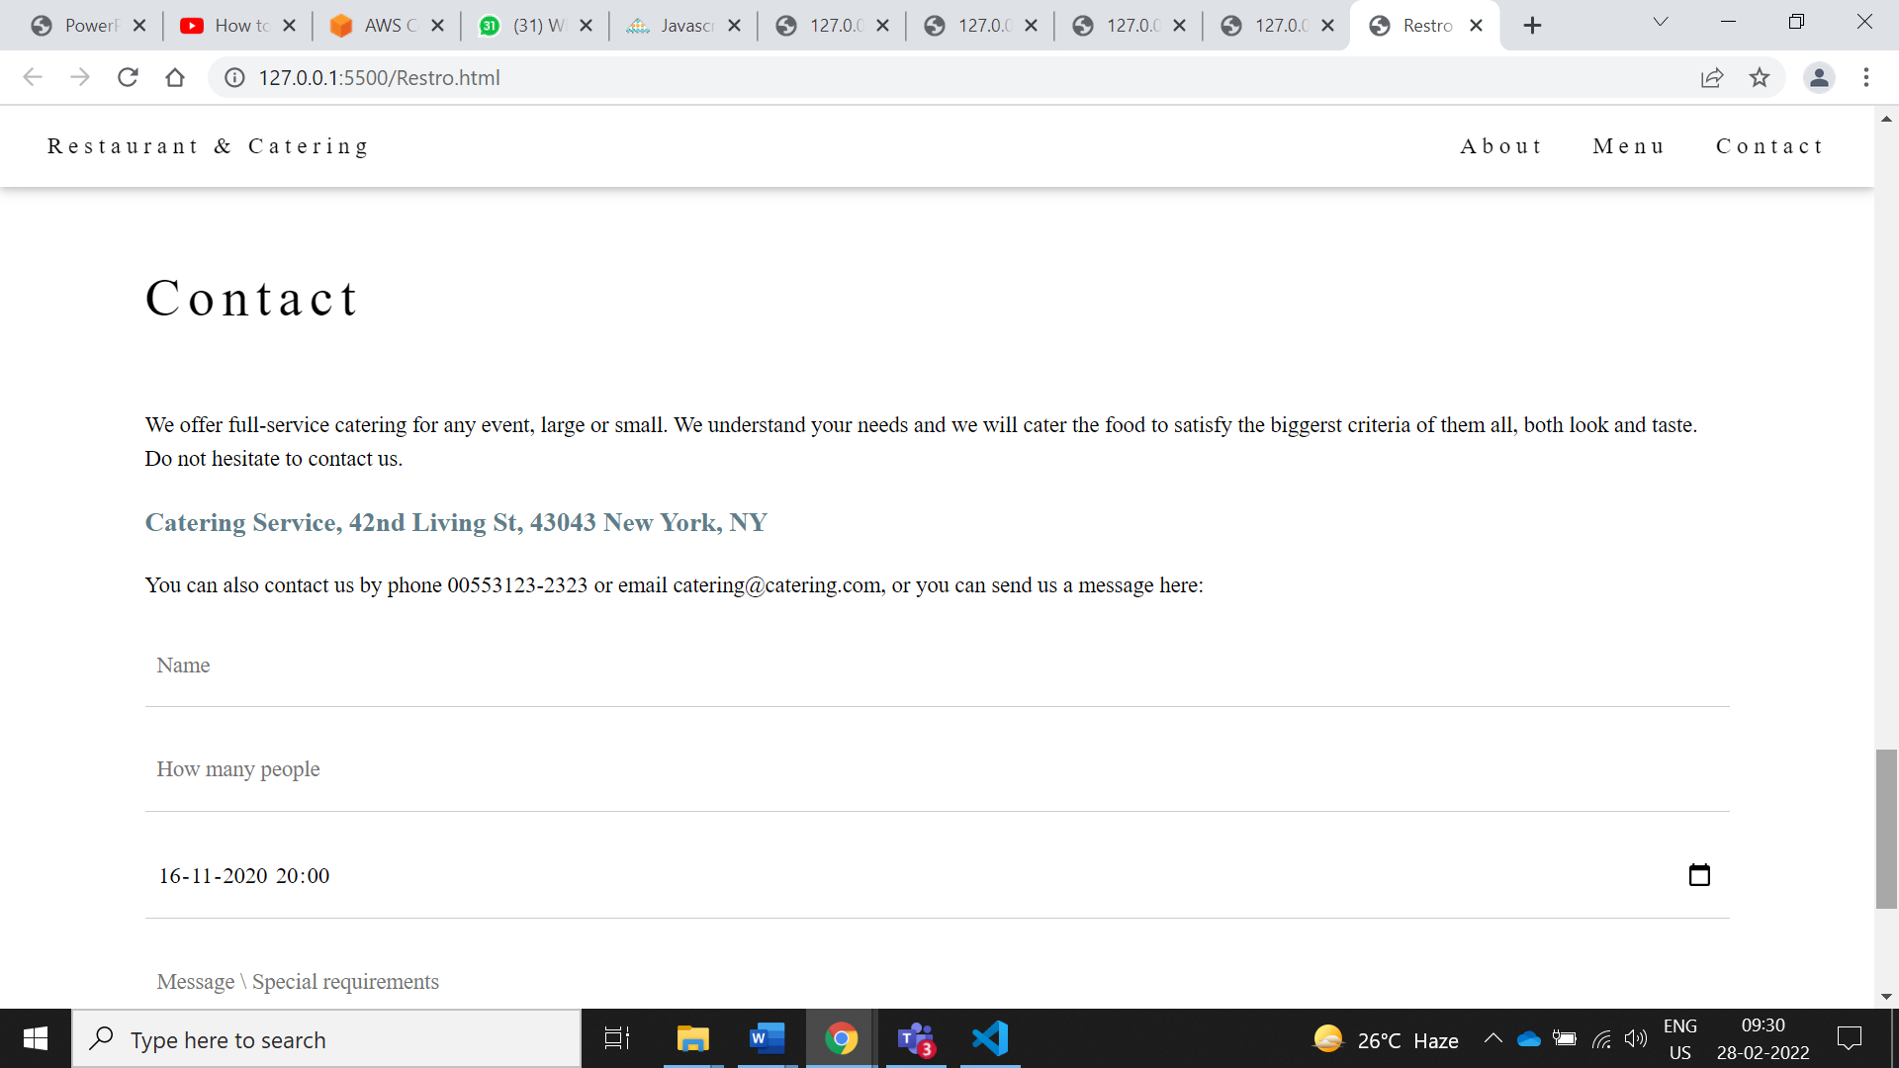

Landing Website :

<!DOCTYPE html>

<html lang='en'>

    <head>

       <meta charset="UTF-8">

            <title>ZUDIO E-commerce website</title>

            <link rel="stylesheet" href="Style.css" >

            <link rel="preconnect" href="https://fonts.googleapis.com">

<link rel="preconnect" href="https://fonts.gstatic.com" crossorigin>

<link href="https://fonts.googleapis.com/css2?family=Poppins:ital,wght@0,300;0,500;0,600;0,700;1,200&display=swap" rel="stylesheet">

<link rel="stylesheet" href="https://cdn.jsdelivr.net/npm/@fortawesome/fontawesome-free@5.15.4/css/fontawesome.min.css">

<link rel="stylesheet" href="https://cdnjs.cloudflare.com/ajax/libs/font-awesome/4.7.0/css/font-awesome.min.css">

    </head>

<body>

    <div class= "header">

    <div class ="container">

         <div class="navbar">

             <div class="logo">

                 <img src="images/logo1.png" width="125">

                 </div>

                 <nav><ul>

                     <li><a href="index.html">Home</a></li>

                     <li><a href="product.html">Product</a></li>

                     <li><a href="about.html">About</a></li>

                     <li><a href="returnpolicy.html">Policies</a></li>

                     <li><a href="register.html">Account</a></li>

                 </ul>

                 </nav>

                 </div>

                 <div class= "row">

                  <div class= "col-2">

 <style>

    blockquote {font-size:larger;}

    .heart {font-size:100%; color:red;font-family:cursive; text-align:right }

    .dream {font-size:170%;font-family:cursive;color:lightblue;}

</style>

            <div>

            <pre>

            </pre>

     <blockquote><h2>Happiness is not <span class="heart">in money</span></br>but<span class="dream">in shopping!!</span></h2></blockquote><br>

</div>

    <p><h3>No matter how or what you shop,

                        <br>we believe this is an occasion worth celebrating. </h3></p>

                          <a href ="" class="btn"> Explore Now &#8594 </a>

                  </div>

                   <div class= "col-2">

                 <img src ="images/image1.png"  width ="60%" height="60%">

                  </div>

                </div>

                </div>

                 </div>

                 <!-------- featured categories---->

    <div class ="categories">

    <div class ="smallContainer">

       <div class="row">

        <div class="col_3">

        <img src="images/groceryFront.jpg">

        <h3>Grocery Shop</h3>

         </div>

         <div class="col_3">

           <img src="images/electronics.png">

           <h3>Electronics Shop</h3>

           </div>

          <div class="col_3">

             <img src="images/hoddie.png">

             <h3>Clothing And Makeup Shop</h3>

              </div>

             </div>

      </div>

</div>

        <!-------- featured products---->

<div class ="smallContainer">

<h2 class="title">Featured Products</h2>

<div class="row">

<div class ="col_4">

<img src="images/zudio7.png">

<h4> Black high neck top </h4>

<div class="rating">

<i class="fa fa-star"></i>

<i class="fa fa-star"></i>

<i class="fa fa-star"></i>

<i class="fa fa-star"></i>

<i class="fa fa-star-half-o"></i>

</div>

<p>$50.00</p>

 </div>

 <div class ="col_4">

<img src="images/watch.png">

<h4> Titen Watch</h4>

<div class="rating">

<i class="fa fa-star"></i>

<i class="fa fa-star"></i>

<i class="fa fa-star"></i>

<i class="fa fa-star"></i>

<i class="fa fa-star"></i>

</div>

<p>$150.00</p>

 </div>

 <div class ="col_4">

<img src="images/sandel.png">

<h4> Luxury pair Sandel  </h4>

<div class="rating">

<i class="fa fa-star"></i>

<i class="fa fa-star"></i>

<i class="fa fa-star"></i>

<i class="fa fa-star-half-o"></i>

<i class="fa fa-star-half-o"></i>

</div>

<p>$90.00</p>

 </div>

 <div class ="col_4">

<img src="images/zudio9.png">

<h4> blue Formal coat suit </h4>

<div class="rating">

<i class="fa fa-star"></i>

<i class="fa fa-star"></i>

<i class="fa fa-star"></i>

<i class="fa fa-star"></i>

<i class="fa fa-star-half-o"></i>

</div>

<p>$110.00</p>

 </div>

 </div>

 <!-------- Latest products---->

 <h2 class="title">Latest Products</h2>

 <div class="row">

<div class ="col_4">

<img src="images/watch1.png">

<h4> Black Belt watch  </h4>

<div class="rating">

<i class="fa fa-star"></i>

<i class="fa fa-star"></i>

<i class="fa fa-star"></i>

<i class="fa fa-star"></i>

<i class="fa fa-star-half-o"></i>

</div>

<p>$50.00</p>

 </div>

 <div class ="col_4">

<img src="images/col4shoe2.png">

<h4>casual shoes</h4>

<div class="rating">

<i class="fa fa-star"></i>

<i class="fa fa-star"></i>

<i class="fa fa-star"></i>

<i class="fa fa-star"></i>

<i class="fa fa-star"></i>

</div>

<p>$150.00</p>

 </div>

 <div class ="col_4">

<img src="images/col4shoe1.png">

<h4> Normal shoes</h4>

<div class="rating">

<i class="fa fa-star"></i>

<i class="fa fa-star"></i>

<i class="fa fa-star"></i>

<i class="fa fa-star-half-o"></i>

<i class="fa fa-star-half-o"></i>

</div>

<p>$90.00</p>

 </div>

 <div class ="col_4">

<img src="images/col4jogger.png">

<h4> Track pant </h4>

<div class="rating">

<i class="fa fa-star"></i>

<i class="fa fa-star"></i>

<i class="fa fa-star"></i>

<i class="fa fa-star"></i>

<i class="fa fa-star-half-o"></i>

</div>

<p>$110.00</p>

 </div>

 </div>

 <div class="row">

<div class ="col_4">

<img src="images/zudio7.png">

<h4> Black high neck top </h4>

<div class="rating">

<i class="fa fa-star"></i>

<i class="fa fa-star"></i>

<i class="fa fa-star"></i>

<i class="fa fa-star"></i>

<i class="fa fa-star-half-o"></i>

</div>

<p>$50.00</p>

 </div>

 <div class ="col_4">

<img src="images/watch.png">

<h4> Luxury pair Sandel</h4>

<div class="rating">

<i class="fa fa-star"></i>

<i class="fa fa-star"></i>

<i class="fa fa-star"></i>

<i class="fa fa-star"></i>

<i class="fa fa-star"></i>

</div>

<p>$150.00</p>

 </div>

 <div class ="col_4">

<img src="images/sandel.png">

<h4> Titen Watch  </h4>

<div class="rating">

<i class="fa fa-star"></i>

<i class="fa fa-star"></i>

<i class="fa fa-star"></i>

<i class="fa fa-star-half-o"></i>

<i class="fa fa-star-half-o"></i>

</div>

<p>$90.00</p>

 </div>

 <div class ="col_4">

<img src="images/zudio9.png">

<h4> blue Formal coat suit </h4>

<div class="rating">

<i class="fa fa-star"></i>

<i class="fa fa-star"></i>

<i class="fa fa-star"></i>

<i class="fa fa-star"></i>

<i class="fa fa-star-half-o"></i>

</div>

<p>$110.00</p>

</div>

 </div>

 </div>

 <!---    -------------------------------Offers-------->

 <div class="offer">

 <div class="smallContainer">

 <div class="row">

 <div class="col-2">

 <img src="images/ex1.png"  class="offerimg2">

  </div>

  <div class="col-2">

  <p>Exclusively Available on Zudio Store</p>

  <h1>Workwear Watch</h1>

  <small>Sober yet enchanting, this muted time piace is the personification of restraint and class! The silver grey two toned dial sets off the pale olive green leather strap nicely, while the rose-gold case adds a contrasting charm. For a woman with no pretensions.</small>

  </br>

  <a href ="buynow.html"   class="btn" >Buy Now &#8594</a>

  </div>

  </div>

 </div>

 </div>

 <!--------testimonial -------------------------------------------------->

 <div class ="testmonial">

 <div class="smallContainer">

 <div class="row">

 <div class ="col_3">

 <i class="fa fa-quote-left"></i>

 <p>Zudio is very nice clothing shop.

 It has own house cloths as well as other brand.you will get great product with best deals.

</p>

 <div class="rating">

 <i class="fa fa-star"></i>

<i class="fa fa-star"></i>

<i class="fa fa-star"></i>

<i class="fa fa-star"></i>

<i class="fa fa-star-half-o"></i>

</div>

<img src="images/zudio12.png">

<h3> Sea pankar</h3>

</div>

 <div class ="col_3">

  <i class="fa fa-quote-left"></i>

 <p>Zudio is  good for all kind of trandy wear.

 Collection for western wear are very decent and dailu wear.

 Also scarfs and scandals are available based on latest fashion trends.

</p>

 <div class="rating">

  <i class="fa fa-star"></i>

<i class="fa fa-star"></i>

<i class="fa fa-star"></i>

<i class="fa fa-star"></i>

<i class="fa fa-star"></i>

</div>

<img src="images/zudio13.png">

<h3>Sid Malhotra</h3>

   </div>

 <div class ="col_3">

 <i class="fa fa-quote-left"></i>

 <p>Summer dress for women are pretty.

 Mostly cloths are cotton.

 Men's wear is also good. Kids wear are also

 available with good price.</p>

 <div class="rating">

 <i class="fa fa-star"></i>

<i class="fa fa-star"></i>

<i class="fa fa-star"></i>

<i class="fa fa-star"></i>

<i class="fa fa-star-half-o"></i>

</div>

<img src="images/zodic11.png">

<h3> Jiya Roy</h3>

   </div>

 </div>

 </div>

 </div>

 <!-------------------Brands------------------->

 <div class ="brand">

 <div class="smallContainer">

 <div class="row">

 <div class ="col_5">

 <a href="https://www.godrejinterio.com/?gclid=CjwKCAjw4qCKBhAVEiwAkTYsPArfJb4Uh8dkUnOu0BaQsu7bTd1OIeAyiYHieAfqg14UagSrCi7VsBoCxDoQAvD_BwE">

 <img src="images/godrej.png" >

 </a>

 </div>

 <div class ="col_5">

 <a href="https://www.coca-colacompany.com/">

 <img src="images/coc1.png" >

 </a>

 </div>

 <div class ="col_5">

 <a href ="https://www.googleadservices.com/pagead/aclk?sa=L&ai=DChcSEwiu1qvzvY_zAhVYmWYCHXPiBNoYABAAGgJzbQ&ohost=www.google.com&cid=CAESQOD2DkQpwKR5OCrD8dbKB6k4S0g5tOBJ8boXDACRv0-HAIWqK8xqB9OlQ7BgebtiAopucW0gFRsyln24344q41g&sig=AOD64_2hOzFZagwgdTU7B1IP58e_jGAcCg&q&nis=1&adurl&ved=2ahUKEwikrqPzvY_zAhUbzjgGHXR1CLIQ0Qx6BAgCEAE">

 <img src="images/paypal.png" >

 </a>

 </div>

 <div class ="col_5">

 <a href="https://www.oppo.com/in/smartphones/series-reno/reno6-pro-5g/?gclid=CjwKCAjw4qCKBhAVEiwAkTYsPJ7_sGseUn9RDxUIgUJj5RTD3vJ7lEThiqRKv8t2jDieuQYExtNaIxoCKPMQAvD_BwE">

 <img src="images/oppo.png" >

 </a>

 </div>

 <div class ="col_5">

 <a href="https://www.philips.co.in/">

 <img src="images/philips.png" >

 </a>

 </div>

 </div>

 </div>

 </div>

 <!--------footer---------------->

 <div class="footer">

 <div class="smallContainer">

 <div class="row">

 <div class="footer_col1">

 <h3>Download Our App</h3>

 <p>download this app for android mobile and mobile phone</p>

 <div class="app_logo">

 <img src="images/google.png">

 <img src="images/apple.png">

 </div>

 </div>

 <div class="footer_col2">

 <img src="images/logo1.png">

 <p>Our perpose is to Sustainably make the Pleasure and Benifits of products Accessible to Many.</p>

 </div>

 <div class="footer_col3">

 <h3>Useful Links</h3>

 <ul>

 <li>Coupons</li>

 <li><a href ="returnpolicy.html">Return policy</a></li>

 <li>Join Affiliate</li>

 </ul>

 </div>

 <div class="footer_col4">

 <h3>Folllow Us </h3>

 <ul>

 <li><a href ="https://www.youtube.com/watch?v=5Wq4V4HCovY">youtube</a></li>

 <li><a href ="mailto: Zudiohelp@trent-tata.com">Gmail</a></li>

 <li><a href ="mailto: Zudiohelp@trent-tata.com">FaceBook</li>

 </ul>

 </div>

 </div>

 <hr><p class="copyright">copyright2020-zudio shop</p></hr>

 </div>

 </div>

    </body>

</html>

Product.html

<html>

    <meta charset="UTF-8">

                <title>Products</title>

    <link rel="stylesheet" href="Style.css" >

    <link rel="preconnect" href="https://fonts.gstatic.com" crossorigin>

    <link href="https://fonts.googleapis.com/css2?family=Poppins:ital,wght@0,300;0,500;0,600;0,700;1,200&display=swap" rel="stylesheet">

    <link rel="stylesheet" href="https://cdn.jsdelivr.net/npm/@fortawesome/fontawesome-free@5.15.4/css/fontawesome.min.css">

    <link rel="stylesheet" href="https://cdnjs.cloudflare.com/ajax/libs/font-awesome/4.7.0/css/font-awesome.min.css">

    <body>

        <div class= "header">

        <div class ="container">

             <div class="navbar">

                 <div class="logo">

                     <img src="images/logo1.png" width="125">

                     </div>

                     <nav><ul>

                         <li><a href="../index.html">Home</a></li>

                         <li><a href="product.html">Product</a></li>

                         <li><a href="about.html">About</a></li>

                         <li><a href="contact.html">Contact</a></li>

                         <li><a href="register2.html">Account</a></li>

                     </ul>

                     </nav>

                     <img src ="images/cartfinal.png" height="30px" width="30px">

             </div>

    <h2 class="title">PRODUCTS</h2>

     <div class="row">

    <div class ="col_4">

    <img src="images/watch1.png">

    <h4> Black Belt watch  </h4>

    <div class="rating">

    <i class="fa fa-star"></i>

    <i class="fa fa-star"></i>

    <i class="fa fa-star"></i>

    <i class="fa fa-star"></i>

    <i class="fa fa-star-half-o"></i>

    </div>

    <p>$50.00</p>

     </div>

     <div class ="col_4">

    <img src="images/col4shoe2.png">

    <h4>casual shoes</h4>

    <div class="rating">

    <i class="fa fa-star"></i>

    <i class="fa fa-star"></i>

    <i class="fa fa-star"></i>

    <i class="fa fa-star"></i>

    <i class="fa fa-star"></i>

    </div>

    <p>$150.00</p>

     </div>

     <div class ="col_4">

    <img src="images/col4shoe1.png">

    <h4> Normal shoes</h4>

    <div class="rating">

    <i class="fa fa-star"></i>

    <i class="fa fa-star"></i>

    <i class="fa fa-star"></i>

    <i class="fa fa-star-half-o"></i>

    <i class="fa fa-star-half-o"></i>

    </div>

    <p>$90.00</p>

     </div>

     <div class ="col_4">

    <img src="/mages/col4jogger.png">

    <h4> Track pant </h4>

    <div class="rating">

    <i class="fa fa-star"></i>

    <i class="fa fa-star"></i>

    <i class="fa fa-star"></i>

    <i class="fa fa-star"></i>

    <i class="fa fa-star-half-o"></i>

    </div>

    <p>$110.00</p>

     </div>

     </div>

     <div class="row">

    <div class ="col_4">

    <img src="images/zudio7.png">

    <h4> Black high neck top </h4>

    <div class="rating">

    <i class="fa fa-star"></i>

    <i class="fa fa-star"></i>

    <i class="fa fa-star"></i>

    <i class="fa fa-star"></i>

    <i class="fa fa-star-half-o"></i>

    </div>

    <p>$50.00</p>

     </div>

     <div class ="col_4">

    <img src="images/watch.png">

    <h4> Luxury pair Sandel</h4>

    <div class="rating">

    <i class="fa fa-star"></i>

    <i class="fa fa-star"></i>

    <i class="fa fa-star"></i>

    <i class="fa fa-star"></i>

    <i class="fa fa-star"></i>

    </div>

    <p>$150.00</p>

     </div>

     <div class ="col_4">

    <img src="images/sandel.png">

    <h4> Titen Watch  </h4>

    <div class="rating">

    <i class="fa fa-star"></i>

    <i class="fa fa-star"></i>

    <i class="fa fa-star"></i>

    <i class="fa fa-star-half-o"></i>

    <i class="fa fa-star-half-o"></i>

    </div>

    <p>$90.00</p>

     </div>

     <div class ="col_4">

    <img src="images/zudio9.png">

    <h4> blue Formal coat suit </h4>

    <div class="rating">

    <i class="fa fa-star"></i>

    <i class="fa fa-star"></i>

    <i class="fa fa-star"></i>

    <i class="fa fa-star"></i>

    <i class="fa fa-star-half-o"></i>

    </div>

    <p>$110.00</p>

    </div>

     </div>

     </div>

     </div>

     <h2 class="title"> Related PRODUCTS</h2>

    <marquee scrollamount="15"><img src="images/zudio7.png" height="300px" width="300px">

    <img src ="images/col4jogger.png" height="300px" width="300px">

    <img src ="images/watch.png" height="300px" width="300px">

    <img src ="images/watch1.png" height="300px" width="300px">

    <img src ="images/z5.png" height="300px" width="300px"></marquee>

    <pre>

    </pre>

    </div>

    </div>

    <!-------FOoter---------->

    <div class="footer">

     <div class="smallContainer">

     <div class="row">

     <div class="footer_col1">

     <h3>Download Our App</h3>

     <p>download this app for android mobile and mobile phone</p>

     <div class="app_logo">

     <img src="images/google.png">

     <img src="images/apple.png">

     </div>

     </div>

     <div class="footer_col2">

     <img src="images/logo1.png">

     <p>Our perpose is to Sustainably make the Pleasure and Benifits of products Accessible to Many.</p>

     </div>

     <div class="footer_col3">

     <h3>Useful Links</h3>

     <ul>

     <li>Coupons</li>

     <li><a href ="returnpolicy.html">Return policy</a></li>

     <li>Join Affiliate</li>

     </ul>

     </div>

     <div class="footer_col4">

     <h3>Folllow Us </h3>

     <ul>

     <li><a href ="https://www.youtube.com/watch?v=5Wq4V4HCovY">youtube</a></li>

     <li><a href ="mailto: Zudiohelp@trent-tata.com">Gmail</a></li>

     <li>FaceBook</li>

     <li>Instagram</li>

     </ul>

     </div>

     </div>

     <hr><p class="copyright">copyright2020-zodio shop</p></hr>

     </div>

     </div>

    </body>

    </html>

About.html

 <html>

    <meta charset="UTF-8">

                <title>About us</title>

    <link rel="stylesheet" href="Style.css" >

    <link rel="preconnect" href="https://fonts.gstatic.com" crossorigin>

    <link href="https://fonts.googleapis.com/css2?family=Poppins:ital,wght@0,300;0,500;0,600;0,700;1,200&display=swap" rel="stylesheet">

    <link rel="stylesheet" href="https://cdn.jsdelivr.net/npm/@fortawesome/fontawesome-free@5.15.4/css/fontawesome.min.css">

    <link rel="stylesheet" href="https://cdnjs.cloudflare.com/ajax/libs/font-awesome/4.7.0/css/font-awesome.min.css">

    <body>

        <div class= "header">

        <div class ="container">

             <div class="navbar">

                 <div class="logo">

                     <img src="../images/logo1.png" width="125">

                     </div>

                     <nav><ul>

                         <li><a href="../index.html">Home</a></li>

                         <li><a href="about.html">About</a></li>

                         <li><a href="returnpolicy.html">Policy</a></li>

                         <li><a href ="mailto: Zudiohelp@trent-tata.com">Contact</a></li>

                         <li><a href="register.html">Account</a></li>

                          <li><a href="admin.html">Admin</a></li>

                     </ul>

                     </nav>

             </div>

    <h1> WHO WE ARE</h1>

     <br>

    A FASHION BRAND FROM - THE HOUSE OF TATA TRENT LTD

    <h3>WHAT WE DO?</h3>

    <p>OFFER IRRESISTIBLE FASHION AT IRRESISTIBLE PRICES

    CONSTANT NEWNESS IN STORE</p>

    <h3>WHERE WE ARE?</h3>

    <p>CURRENTLY IN 42 CITIES IN INDIA, COMING TO YOUR CITY VERY SOON</p>

    <pre>

    </pre>

    <marquee scrollamount="15">

    <img src ="../images/z1.png" height="300px" width="300px">

    <img src ="../images/z4.png" height="300px" width="300px">

    <img src ="../images/z3.png" height="300px" width="300px">

    <img src ="../images/z1.png" height="300px" width="300px">

    <img src ="../images/z5.png" height="300px" width="300px"></marquee>

    </div>

    </div>

    <!-------FOoter---------->

    <div class="footer">

     <div class="smallContainer">

     <div class="row">

     <div class="footer_col1">

     <h3>Download Our App</h3>

     <p>download this app for android mobile and mobile phone</p>

     <div class="app_logo">

     <img src="images/google.png">

     <img src="images/apple.png">

     </div>

     </div>

     <div class="footer_col2">

     <img src="images/logo1.png">

     <p>Our perpose is to Sustainably make the Pleasure and Benifits of products Accessible to Many.</p>

     </div>

     <div class="footer_col3">

     <h3>Useful Links</h3>

     <ul>

     <li>Coupons</li>

     <li><a href ="returnpolicy.html">Return policy</a></li>

     <li>Join Affiliate</li>

     </ul>

     </div>

     <div class="footer_col4">

     <h3>Folllow Us </h3>

     <ul>

     <li><a href ="https://www.youtube.com/watch?v=5Wq4V4HCovY">youtube</a></li>

     <li><a href ="mailto: Zudiohelp@trent-tata.com">Gmail</a></li>

     <li>FaceBook</li>

     <li>Instagram</li>

     </ul>

     </div>

     </div>

     <hr><p class="copyright">copyright2020-zodio shop</p></hr>

     </div>

     </div>

    </body>

    </html>

Pay.html

<html>

    <meta charset="UTF-8">

                <title>Buy Now</title>

    <link rel="stylesheet" href="Style.css" >

    <link rel="stylesheet" href="https://cdn.jsdelivr.net/npm/@fortawesome/fontawesome-free@5.15.4/css/fontawesome.min.css">

    <link rel="stylesheet" href="https://cdnjs.cloudflare.com/ajax/libs/font-awesome/4.7.0/css/font-awesome.min.css">

    <body>

        <div class= "header">

        <div class ="container">

             <div class="navbar">

                 <div class="logo">

                     <img src="images/logo1.png" width="125">

                     </div>

                     <nav><ul>

                         <li><a href="../index.html">Home</a></li>

                         <li><a href="produt.html">Product</a></li>

                         <li><a href="about.html">About</a></li>

                         <li><a href ="mailto: Zudiohelp@trent-tata.com">Contact</a></li>

                         <li><a href="register.html">Account</a></li>

                     </ul>

                     </nav>

                     <img src ="images/cartfinal.png" height="30px" width="30px">

             </div>

    <div class ="smallContainer">

    <h2 class="title">Exclusive Product Is Here</h2>

    <div class="row">

    <div class ="col_2">

    <img align="right" src="images/ex1.png"   class="buyimg">

    <h4 align="left">Workwear Watch</h4>

    <h5><Workwear Watch with Grey Dial Leather Strap | TITAN></h5>

    <div class="rating">

    <i class="fa fa-star"></i>

    <i class="fa fa-star"></i>

    <i class="fa fa-star"></i>

    <i class="fa fa-star"></i>

    <i class="fa fa-star-half-o"></i>

    </div>

    <p>$150.00</p>

    <a href ="https://www.google.com/shopping/product/5380727059381240209?lsf=seller:103307561,store:7440424354714918160,s:b&prds=oid:9549940941379418363&q=watches+for+women&hl=en&ei=HKJJYemaMZ-Z4-EPnYObwAI&utm_source=Google&utm_medium=CPC&utm_campaign=2051582043&utm_term&lsft=gclid:CjwKCAjwhaaKBhBcEiwA8acsHCMwbDg7PPWmOGKpdyCDVZAQ---Pjfe672gQ6K8LIKqqCMnr4tv8PxoCu-YQAvD_BwE"><button class="button button1">Add to cart</button></a>

    <a href ="https://www.google.com/shopping/product/5380727059381240209?lsf=seller:103307561,store:7440424354714918160,s:b&prds=oid:9549940941379418363&q=watches+for+women&hl=en&ei=HKJJYemaMZ-Z4-EPnYObwAI&utm_source=Google&utm_medium=CPC&utm_campaign=2051582043&utm_term&lsft=gclid:CjwKCAjwhaaKBhBcEiwA8acsHCMwbDg7PPWmOGKpdyCDVZAQ---Pjfe672gQ6K8LIKqqCMnr4tv8PxoCu-YQAvD_BwE"><button class="button button2">Buy Now</button></a>

     </div>

    </div>

    </div>

    <!-- related product -->

    <div class ="smallContainer">

    <h2 class="title">Related Products</h2>

    <div class="row">

    <div class ="col_4">

    <img src="images/watch2.png">

    <h4>Stylist watch</h4>

    <div class="rating">

    <i class="fa fa-star"></i>

    <i class="fa fa-star"></i>

    <i class="fa fa-star"></i>

    <i class="fa fa-star"></i>

    <i class="fa fa-star-half-o"></i>

    </div>

    <p>$50.00</p>

     </div>

     <div class ="col_4">

    <img src="images/watch.png">

    <h4> Titen Watch</h4>

    <div class="rating">

    <i class="fa fa-star"></i>

    <i class="fa fa-star"></i>

    <i class="fa fa-star"></i>

    <i class="fa fa-star"></i>

    <i class="fa fa-star"></i>

    </div>

    <p>$150.00</p>

     </div>

     <div class ="col_4">

    <img src="images/watch3.png">

    <h4>Women branded luxury leather watch</h4>

    <div class="rating">

    <i class="fa fa-star"></i>

    <i class="fa fa-star"></i>

    <i class="fa fa-star"></i>

    <i class="fa fa-star-half-o"></i>

    <i class="fa fa-star-half-o"></i>

    </div>

    <p>$90.00</p>

     </div>

     <div class ="col_4">

    <img src="images/watch4.png">

    <h4> Stylist watch </h4>

    <div class="rating">

    <i class="fa fa-star"></i>

    <i class="fa fa-star"></i>

    <i class="fa fa-star"></i>

    <i class="fa fa-star"></i>

    <i class="fa fa-star-half-o"></i>

    </div>

    <p>$110.00</p>

     </div>

     </div>

     </div>

    <!--------footer---------------->

     <div class="footer">

     <div class="smallContainer">

     <div class="row">

     <div class="footer_col1">

     <h3>Download Our App</h3>

     <p>download this app for android mobile and mobile phone</p>

     <div class="app_logo">

     <img src="images/google.png">

     <img src="images/apple.png">

     </div>

     </div>

     <div class="footer_col2">

     <img src="images/logo1.png">

     <p>Our perpose is to Sustainably make the Pleasure and Benifits of products Accessible to Many.</p>

     </div>

     <div class="footer_col3">

     <h3>Useful Links</h3>

     <ul>

     <li>Coupons</li>

     <li><a href ="returnpolicy.html">Return policy</a></li>

     <li>Join Affiliate</li>

     </ul>

     </div>

     <div class="footer_col4">

     <h3>Folllow Us </h3>

     <ul>

     <li><a href ="https://www.youtube.com/watch?v=5Wq4V4HCovY">youtube</a></li>

     <li><a href ="mailto: Zudiohelp@trent-tata.com">Gmail</a></li>

     <li>FaceBook</li>

     <li>Instagram</li>

     </ul>

     </div>

     </div>

     <hr><p class="copyright">copyright2020-zodio shop</p></hr>

     </div>

     </div>

     </div>

       </div>

    </body>

    </html>

Style.css

*{

    margin:0;

    padding:0;

   box-sizing: border-box;

}

body{

    font-family: 'Poppins', sans-serif;

}

.navbar{

    display:flex;

    align-items:center;

    padding:20px;

}

nav{

    flex:1;

    text-align:right;

}

nav ul{

    display: inline-block;

    list-style-type:none;

}

nav ul li{

    display :inline-block;

    margin-right:20px;

}

a{

    text-decoration: none;

    color:#555

}

p{

color:#555

}

.container{

    max-width:1300px;

    margin:auto;

    padding-left:25px;

    padding-right:25px

}

.row{

    display:flex;

    align-items:center;

    flex-wrap:wrap;

    justify-content:space-around;

}

.col-2{

        flex-basis:50%;

        min-width:300px;

    }

.col-2 img{

    background-size:cover;

    background-repeat:no-repeat;

    background-position:center;

    max-width:100%;

    padding: 50px 0;

}

.col-2 h1{

    font-size:50px;

    line-height:60px;

    margin: 25px 0;

}

.btn{

    display:inline-block;

    background:#ff523b;

    color:#fff;

    padding:8px 30px;

    margin: 30px 0;

    border-radius:30px;

    transition: background 0.5s;

}

.btn:hover{

    background-color:#563434;

}

.header{

    background-position:center;

    background: radial-gradient(#fff,#ffd6d6);

}

.header .row{

    margin-top:70px;

}

.categories{

    margin: 70px 0;

}

.col_3:hover{

    transition: background 0.5s;

    transform: translateY(-5px);

}

.col_3{

    flex-basis:30%;

    min-width:250px;

    margin-bottom:30px;

    color:#777;

}

.col_3 img{

    width:100;

}

.smallContainer{

    max-width:1280px;

    margin: auto;

    padding-left:25px;

    padding-right:25px;

}

.col_4{

    flex-basis:10%;

    padding:10px;

    min-width:100px;

    margin-bottom:50px;

    transition: transform o.5s;

}

.col_4 img{

    width:100;

}

.title{

    text-align:center;

    margin: 0px auto 60px;

    position:relative;

    line-height: 60px;

    color:#555;

}

.title::before{

    content:'';

    background:#ff523b;

    width:80px;

    height: 5px;

    border-radius:10px;

    position:absolute;

    bottom:0;

    left:50%;

    transform: translateX(-50%);

}

.col_4{

    color:#555;

    font-weight:normal;

}

.col_4 .p{

    font-size:16px;

}

.rating .fa{

    color:#ff523b;

}

.col_4 :hover{

    transform: translateY(-5px);

}

.offer{

        background: radial-gradient(#fff,#ffd6d6);

        margin:50px;

        padding: 10px 0;

}

.col-2 .offerimg2{

    padding:5px;

}

.small{

    color:#555;

}

/*-------------------tesomonial---------------- */

.testmonial{

    padding-top: 100px;

}

.testmonial .col_3{

    text-align:center;

    padding: 40px 20px;

    box-shadow:0 0 20px 0px rgba(0,0,0,0.1);

    cursor: pointer;

    transition: transform 0.5s;

}

.testmonial .col_3 img{

    width:50px;

    margin-top:20px;

    border-radius:50%;

    margin:auto;

}

.testmonial .col_3:hover{

    transform: translateY(-10px);

}

.fa.fa-quote-left{

    font-size:34px;

    color:#ff523b;

}

.col_3 p{

font-size:12px;

margin:12px 0;

color:#777;

}

.testmonial .col_3 h3{

    font-weight:600;

    color:#555;

    font-size:16px;

}

/*-------------------------BRands-----*/

.brand{

    margin: 100px auto;

}

.brand .col_5{

    width:160px;

}

.col_5 img{

    width:100%;

    cursor:pointer;

    filter: grayscale(100%);

}

.col_5 img:hover{

    filter: grayscale(0);

}

/*-------------------------footer----*/

.footer{

    background:#000;

    color:#8a8a8a;

    font-size: 15px;

    padding:110px 0px 20px;

}

.footer p{

    color :#8a8a8a;;

}

.footer h3{

    color:#fff;

    margin-bottom:20px;

}

.footer_col1,.footer_col2, .footer_col3, .footer_col4{

    min-width:200px;

    margin-bottom:20px;

}

.footer_col1{

    flex-basis:40%;

}

.footer_col2{

    flex:1;

    text-align: center;

}

.footer_col2 img{

    width:180px;

    margin-bottom:20px;

}

.footer_col3 , .footer_col4{

    flex-basis:12%;

    text-align:center;

}

ul{

    list-style-type:none;

}

.app_logo{

    margin-top:20px;

}

.app_logo img{

    width :140px;

}

.footer hr{

    border:none;

     background:#b5b5b5;

     height:1px;

     margin: 20px 0;

}

.copyright{

    text-align:center;

}

/*-------------------buy now-----------*/

.col_2 .buyimg{

    padding:30px;

    width:300px;

    margin-bottom:20px;

    background:radial-gradient(#fff,#ffd6d6);

    align-items: right;

}

.col_2:hover{

    transform: translateY(5px);

}

table, th, td {

  border: 1px solid black;

  border-collapse: collapse;

}

table.center {

  margin-left: auto;

  margin-right: auto;

}

.button {

  border: none;

  color: white;

  padding: 15px 32px;

  text-align: center;

  text-decoration: none;

  display: inline-block;

  font-size: 16px;

  margin: 4px 2px;

  cursor: pointer;

}

.button1 {background-color: #4CAF50; padding: 15px 32px ;} /* Green */

.button2 {background-color: #ff523b;}

/*-------Registration Page -------------------*/

*{

    margin:0;

    padding:0;

}

.container1{

    width:100%;

    height:100vh;

    font-family:sans-serif;

    background: rgb(187,187,245);

    color:#fff;

    display:flex;

    align-items:center;

    justify-content:center;

}

.card{

    width:350px;

    height:500px;

    box-shadow:0 0 40px 20px rgba(0,0,0,0.26);

    perspective:1000px;

    transition: transform 1s;

}

.inner-box{

    position:relative;

    width:100%;

    height:100%;

    transform:rotateY(-180deg);

     transform-style:preserve-3d ;

}

.card-front, .card-back{

    position: absolute;

    width:100%;

    height:100%;

    background-position:center;

    background-size:cover;

    background-image:linear-gradient(rgba(0,0,100,0.8),rgba(0,0,100,0.8)), url("C:\Users\Sarika\Desktop\zodio website\zudio6.jpg");

    padding:55px;

    box-sizing:border-box;

    backface-visibility:hidden;

}

.card-back{

    transform:rotateY(180deg);

}

.card h2{

    font-weight:normal;

    font-size:24px;

    text-align:center;

    margin-bottom:20px;

}

.input-box{

    width:100%;

    background:transparent;

    border: 1px solid #fff;

    margin:6px 0;

    height:32px;

    border-radius: 20px;

    padding:0 10px;

    box-sizing:border-box;

    outline:none;

    text-align:center;

    color: #fff;

}

::placeholder{

    color:#fff;

    font-size:12px;

}

button{

    width:100%;

    background:transparent;

    border:1px solid #fff;

    margin: 35px 0 10px;

    height:32px;

    font-size:12px;

    border-radius:20px;

    padding:0 10px;

    box-sizing: border-box;

    outline:none;

    color:#fff;

    cursor:pointer;

}

.submit-btn{

    position:relative;

}

span{

    font-size:13px;

    margin-left:10px;

}

.card .btn{

    margin-top:70px;

}

.card a{

    color:#fff;

    text-decoration:none;

    display:block;

    text-align:center;

    font-size:13px;

    margin-top:8px;

}

/*-------Registration Page -------------------*/

.login-form {

    width:350px;

    top:50%;

    left:50%;

    transform: translate(-50%,-50%);

    position: absolute;

}

.login-form h1{

    font-size:40px;

    text-align:center;

    text-transform:uppercase;

    margin:40px 0;

}

.login-form p{

    font-size:20px;

    margin:15px 0;

}

.login-form input{

    font-size:17px;

    width:100%;

    padding:15px 10px;

    border:0;

    outline:none;

    border-radius:5px;

}

.login-form button{

    font-size:18px;

    font-weight:bold;

    margin:20px 0;

    padding:10px 15px;

    width:50%;

    border-radius:5px;

    border:0;

}

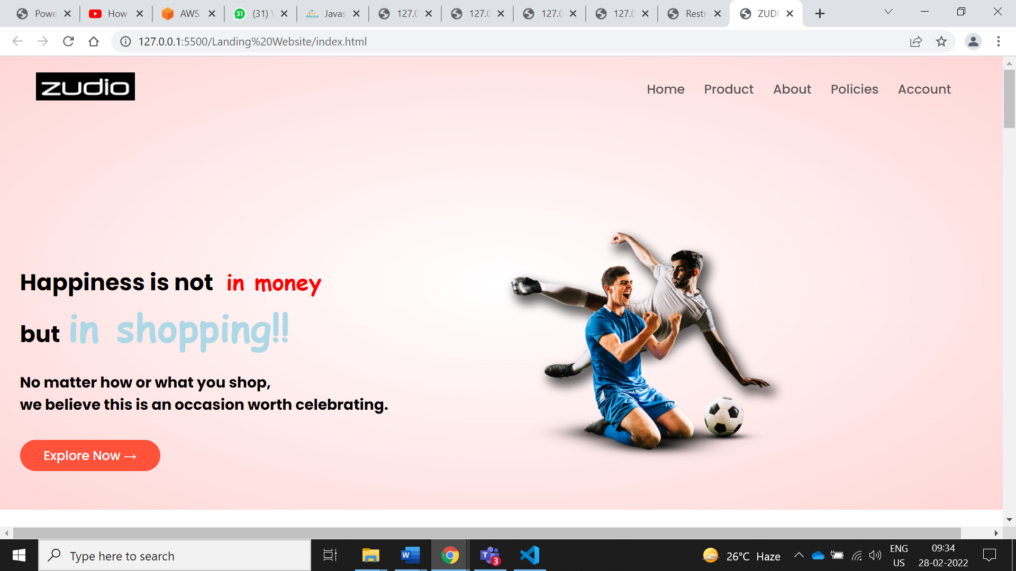

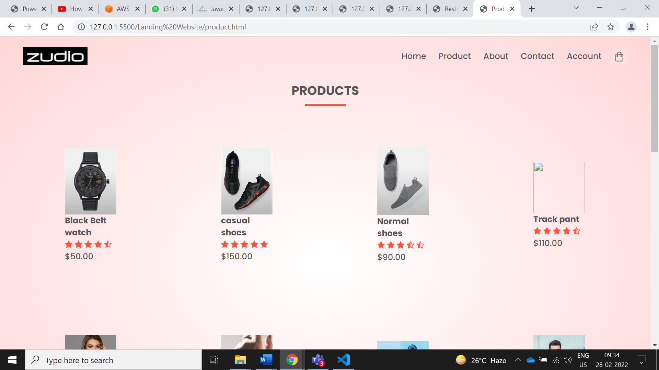

Portfolio Website ….

<!DOCTYPE html>

<html>

<head>

    <title>Portfolio website</title>

    <link rel="stylesheet" type="text/css" href="css/style.css">

    <link rel="preconnect" href="https://fonts.gstatic.com">

  <link href="https://fonts.googleapis.com/css2?family=Josefin+Sans:ital,wght@0,100;0,200;0,300;0,400;0,500;0,600;0,700;1,100;1,200;1,300;1,400;1,500;1,600;1,700&display=swap" rel="stylesheet">

  <link rel="stylesheet" href="https://cdnjs.cloudflare.com/ajax/libs/font-awesome/5.15.3/css/all.min.css" integrity="sha512-iBBXm8fW90+nuLcSKlbmrPcLa0OT92xO1BIsZ+ywDWZCvqsWgccV3gFoRBv0z+8dLJgyAHIhR35VZc2oM/gI1w==" crossorigin="anonymous" referrerpolicy="no-referrer" />

</head>

<body>

    <!----hero Section start---->

    <div class="hero">

        <nav>

            <h2 class="logo">Portfo<span>lio</span></h2>

            <ul>

                <li><a href="#">Home</a></li>

                <li><a href="#">About Us</a></li>

                <li><a href="#">Services</a></li>

                <li><a href="#">Skills</a></li>

                <li><a href="#">Contact Us</a></li>

            </ul>

            <a href="#" class="btn">Subscribe</a>

        </nav>

        <div class="content">

            <h4>Hello, my name is</h4>

            <h1>Chadokar <span>Sarika</span></h1>

            <h3>I'am a Software Developer/Analyst.</h3>

            <div class="newslatter">

                <form>

                    <input type="email" name="email" id="mail" placeholder="Enter Your Email">

                    <input type="submit" name="submit" value="Lets Start">

                </form>

            </div>

        </div>

    </div>

    <!----About section start---->

    <section class="about">

        <div class="main">

            <img src="img/img.jpg">

            <div class="about-text">

                <h2>About Me</h2>

                <h5>Developer <span>& Designer</span></h5>

                <p>I am a full Stack developer. I can provide clean code and pixel perfect design. I also make the website more & more interactive with web animations.I can provide clean code and pixel perfect design. I also make the website more & more interactive with web animations.A responsive design makes your website accessible to all users, regardless of their device.</p>

                <button type="button">Let's Talk</button>

            </div>

        </div>

    </section>

    <!-----service section start----------->

    <div class="service">

        <div class="title">

            <h2>Our Services</h2>

        </div>

        <div class="box">

            <div class="card">

                <i class="fas fa-bars"></i>

                <h5>Software Development</h5>

                <div class="pra">

                    <p>Every website should be built with two primary goals: Firstly, it needs to work across all devices. Secondly, it needs to be fast as possible.</p>

                    <p style="text-align: center;">

                        <a class="button" href="#">Read More</a>

                    </p>

                </div>

            </div>

            <div class="card">

                <i class="far fa-user"></i>

                <h5>Web Development</h5>

                <div class="pra">

                    <p>Every website should be built with two primary goals: Firstly, it needs to work across all devices. Secondly, it needs to be fast as possible.</p>

                    <p style="text-align: center;">

                        <a class="button" href="#">Read More</a>

                    </p>

                </div>

            </div>

            <div class="card">

                <i class="far fa-bell"></i>

                <h5>full stack Development</h5>

                <div class="pra">

                    <p>Every website should be built with two primary goals: Firstly, it needs to work across all devices. Secondly, it needs to be fast as possible.</p>

                    <p style="text-align: center;">

                        <a class="button" href="#">Read More</a>

                    </p>

                </div>

            </div>

        </div>

    </div>

    <!------Contact Me------>

    <div class="contact-me">

        <p>Let Me Get You A Beautiful Website.</p>

        <a class="button-two" href="#">Hire Me</a>

    </div> *{

    padding: 0;

    margin: 0;

    font-family: 'Josefin Sans', sans-serif;

    box-sizing: border-box;

}

.hero{

    height: 100vh;

    width: 100%;

    background-image: url(../img/main.jpg);

    background-size: cover;

    background-position: center;

}

nav{

    display: flex;

    align-items: center;

    justify-content: space-between;

    padding-top: 45px;

    padding-left: 8%;

    padding-right: 8%;

}

.logo{

    color: white;

    font-size: 35px;

    letter-spacing: 1px;

    cursor: pointer;

}

span{

    color: #f9004d;

}

nav ul li{

    list-style-type: none;

    display: inline-block;

    padding: 10px  25px;

}

nav ul li a{

    color: white;

    text-decoration: none;

    font-weight: bold;

    text-transform: capitalize;

}

nav ul li a:hover{

    color: #f9004d;

    transition: .4s;

}

.btn{

    background-color:#f9004d;

    color: white;

    text-decoration: none;

    border: 2px solid transparent;

    font-weight: bold;

    padding: 10px 25px;

    border-radius: 30px;

    transition: transform .4s;

}

.btn:hover{

    transform: scale(1.2);

}

.content{

    position: absolute;

    top: 50%;

    left:8%;

    transform: translateY(-50%);

}

h1{

    color: white;

    margin: 20px 0px 20px;

    font-size: 75px;

}

h3{

    color: white;

    font-size: 25px;

    margin-bottom: 50px;

}

h4{

    color: #fcfc;

    letter-spacing: 2px;

    font-size: 20px;

}

.newslatter form{

    width: 380px;

    max-width: 100%;

    position: relative;

}

.newslatter form input:first-child{

    display: inline-block;

    width: 100%;

    padding: 14px 130px 14px 15px;

    border: 2px solid #f9004d;

    outline: none;

    border-radius: 30px;

}

.newslatter form input:last-child{

    position: absolute;

    display: inline-block;

    outline: none;

    border: none;

    padding: 10px 30px;

    border-radius: 30px;

    background-color:#f9004d;

    color: white;

    box-shadow: 0px 0px 5px #000, 0px 0px 15px #858585;

    top: 6px;

    right: 6px;

}

.about{

    width: 100%;

    padding: 100px 0px;

    background-color: #191919;

}

.about img{

    height: auto;

    width: 430px;

}

.about-text{

    width: 550px;

}

.main{

    width: 1130px;

    max-width: 95%;

    margin: 0 auto;

    display: flex;

    align-items: center;

    justify-content: space-around;

}

.about-text h2{

    color: white;

    font-size: 75px;

    text-transform: capitalize;

    margin-bottom: 20px;

}

.about-text h5{

    color: white;

    letter-spacing: 2px;

    font-size: 22px;

    margin-bottom: 25px;

    text-transform: capitalize;

}

.about-text p{

    color: #fcfc;

    letter-spacing: 1px;

    line-height: 28px;

    font-size: 18px;

    margin-bottom: 45px;

}

button{

    background-color:#f9004d;

    color: white;

    text-decoration: none;

    border: 2px solid transparent;

    font-weight: bold;

    padding: 13px 30px;

    border-radius: 30px;

    transition: .4s;

}

button:hover{

    background-color: transparent;

    border: 2px solid #f9004d;

    cursor: pointer;

}

.service{

    background: #101010;

    width: 100%;

    padding: 100px 0px;

}

.title h2{

    color: white;

    font-size: 75px;

    width: 1130px;

    margin: 30px auto;

    text-align: center;

}

.box{

    display: flex;

    justify-content: center;

    align-items: center;

    min-height: 400px;

}

.card{

    height: 365px;

    width: 335px;

    padding: 20px 35px;

    background: #191919;

    border-radius: 20px;

    margin: 15px;

    position: relative;

    overflow: hidden;

    text-align: center;

}

.card i{

    font-size: 50px;

    display: block;

    text-align: center;

    margin: 25px 0px;

    color: #f9004d;

}

h5{

    color: white;

    font-size: 23px;

    margin-bottom: 15px;

}

.pra p{

    color: #fcfc;

    font-size: 16px;

    line-height: 27px;

    margin-bottom: 25px;

}

.card .button{

    background-color:#f9004d;

    color: white;

    text-decoration: none;

    border: 2px solid transparent;

    font-weight: bold;

    padding: 9px 22px;

    border-radius: 30px;

    transition: .4s;

}

.card .button:hover{

    background-color: transparent;

    border: 2px solid #f9004d;

    cursor: pointer;

}

.contact-me{

    width: 100%;

    height: 290px;

    background: #191919;

    display: flex;

    align-items: center;

    flex-direction: column;

    justify-content: center;

}

.contact-me p{

    color: white;

    font-size: 30px;

    font-weight: bold;

    margin-bottom: 25px;

}

.contact-me .button-two{

    background-color:#f9004d;

    color: white;

    text-decoration: none;

    border: 2px solid transparent;

    font-weight: bold;

    padding: 13px 30px;

    border-radius: 30px;

    transition: .4s;

}

.contact-me .button-two:hover{

    background-color: transparent;

    border: 2px solid #f9004d;

    cursor: pointer;

}

footer{

    position: relative;

    width: 100%;

    height: 400px;

    background: #101010;

    display: flex;

    flex-direction: column;

    align-items: center;

    justify-content: center;

}

footer p:nth-child(1){

    font-size: 30px;

    color: white;

    margin-bottom: 20px;

    font-weight: bold;

}

footer p:nth-child(2){

    color: white;

    font-size: 17px;

    width: 500px;

    text-align: center;

    line-height: 26px;

}

.social{

    display: flex;

}

.social a{

    width: 45px;

    height: 45px;

    display: flex;

    align-items: center;

    justify-content: center;

    background:  #f9004d;

    border-radius: 50%;

    margin: 22px 10px;

    color: white;

    text-decoration: none;

    font-size: 20px;

}

.social a:hover{

    transform: scale(1.3);

    transition: .3s;

}

.end{

    position: absolute;

    color:#f9004d;

    bottom: 35px;

    font-size: 14px;

}

            <a href="#"><i class="fab fa-facebook-f"></i></a>

            <a href="#"><i class="fab fa-instagram"></i></a>

            <a href="#"><i class="fab fa-dribbble"></i></a>

        </div>

        <p class="end">CopyRight By Sarika Chadokar</p>

    </footer>

</body>

</html>

